Project Plan - Tech-Rex



# Group Information

Name: Tech-Rex

Members:

* Daniel van Dijk
* Ryan Meijs
* Jue Wang
* Surya Giri

# Project Statement

### **Formal Client**

Jolaro Guil. CEO of E-Vents

### **Our Team**

Daniel van Dijk

Position: Project Leader

Phone: +31641487488

E-mail: [daniel.vandijk@student.fontys.nl](mailto:daniel.vandijk@student.fontys.nl)

Ryan Meijs

Position: Project Secretary

Phone: +31625160134

E-mail: [r.meijs@student.fontys.nl](mailto:r.meijs@student.fontys.nl)

Jue Wang

Position: Project Manager

Phone: +31638494159

E-mail: [jue.wang@student.fontys.nl](mailto:jue.wang@student.fontys.nl)

Surya Giri

Position: Project Member

Phone: +31628956228

Email: [surya.giri@student.fontys.nl](mailto:surya.giri@student.fontys.nl)

### **Current Situation**

* Jolaro Guil’s organisation (E-Vents) is organizing a music festival. They contacted our team with the assignment to deliver a system for the event.

### **Problem**

E-Vents does not have a system to run their event.

### **Goal**

The goal is to create the system that E-Vents is asking for, which will allow visitors to register for the event, reserve a camping spot, discuss the event with others as well as to keep track of reservations and allow for use of credits to purchase foods, drinks, and materials during the event.

### **Deliverables**

* Website that allows visitors to register for the event, reserve a camping spot, and post “tweets”
* A database for the event
* An authenticator application for use at the entrance of the event, to verify the identity of the visitor
* An application to determine whether visitors on the camping grounds have paid enough for their camping spot
* An application to be used by the food and drink stands, to generate a sales receipt, check the customer ID and remove the balance from their event-account
* An application to be used by the rented material stands, which uses the customer’s event-account to pay for the materials. It should also keep track of loaned materials.
* An application used when a visitor leaves the event, which (assuming the visitor returned all borrowed materials) returns the remaining balance on their event-account to the visitor
* An application to transfer information from the logfiles sent by Paypal during the event into the database of the event.’
* An application for the organisation to see the status of the system including:
  + How many visitors are there?
  + How many visitors have left?
  + What’s the total balance of the event-accounts?
  + What’s the status of a certain visitor?
  + More (ask the client)

### **Non-Deliverables**

We won’t deliver anything not included in the “Deliverables”-section

### **Constraints**

* 18 workweeks. The system must be finished by week 16
* Website should run on the Athena server of Fontys, using html, css, Javascript and php.
* The database made with Oracle database or MySQL
* Windows application programmed in a object-oriented language.

### **Risks**

* **Unexpected time delays:** Many things can happen that will bring delays to our project, such as unfulfilled promises from some of the group members, illnesses, and miscommunication.
  + **Impact:** Medium. Some tasks rely on the completion of others, meaning delays in certain tasks will bring more delays to the further tasks.
  + **Probability:** Medium. There are many different ways delays can occur.
  + **Solution:** Transferring workload unto other group members, or hiring temporary assistance.
  + **Prevention:** Prevention is difficult, as these are *unexpected* delays. But we can lower the possible impact by staying ahead of schedule, so that delays won’t be as big an issue.

# Project Phasing

*What milestones are there?*

1. Version 1 of every system (application, website, database) This is the startup. Design and basic implementation.
2. Final versions and deliverables

*What tasks are there?*

**Block 1**

1. Project plan
2. Setup-Document
3. Website version 1(design)
4. Database version 1(design and DBMS startup)
5. Application version 1(design and classes)

**Block 2**

6. Website version 2 (Registration/reservation possible, using PHP)

7. Database final version (Functionality with website to add information to the database,

and give information to the applications)

8. Application final version (Completely functional. This may be split into smaller tasks,

such as setting up each section of the applications)

9. Website final version (Allow discussion on the website. Twitter functionality is a **should.**

Facebook is a **could**)

*Time division?*

**Week 1-3**: Plan the structure of the system and the event. Start the project plan and setup-document

**Week 4-6:** Website design, Database design and application design. Finish the first set of deliverables. This is Milestone 1

**Week 7:** Finish the setup-document.

**Week 8-9:** Exams. No tasks

**Week 11-17:** Finish the tasks of block 2. This is broad and will be expanded on in the second block. This is Milestone 2.

*Critical path?*

The most important and time consuming section of the system is the website, as everything starts with and interacts with the website

## Project Phasing diagram

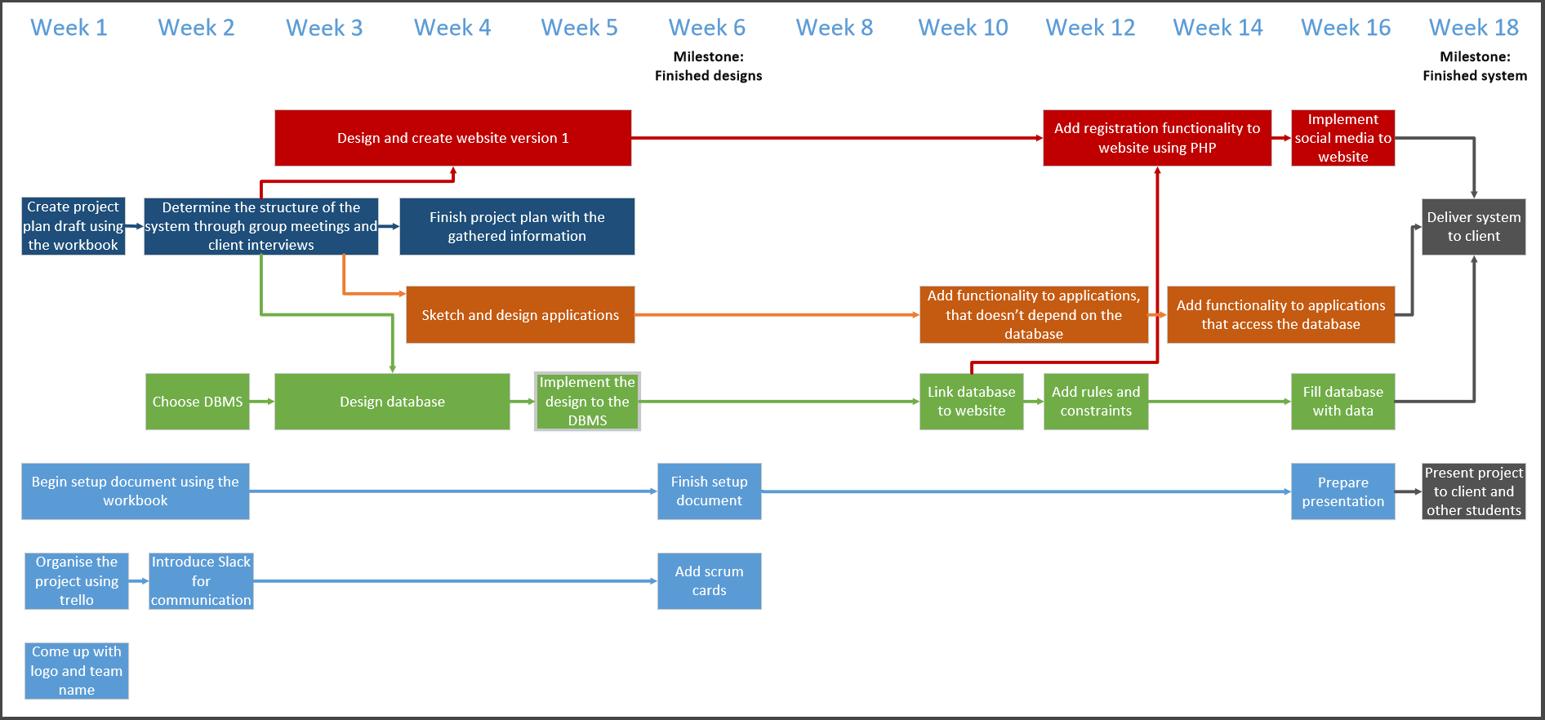

# Gantt chart

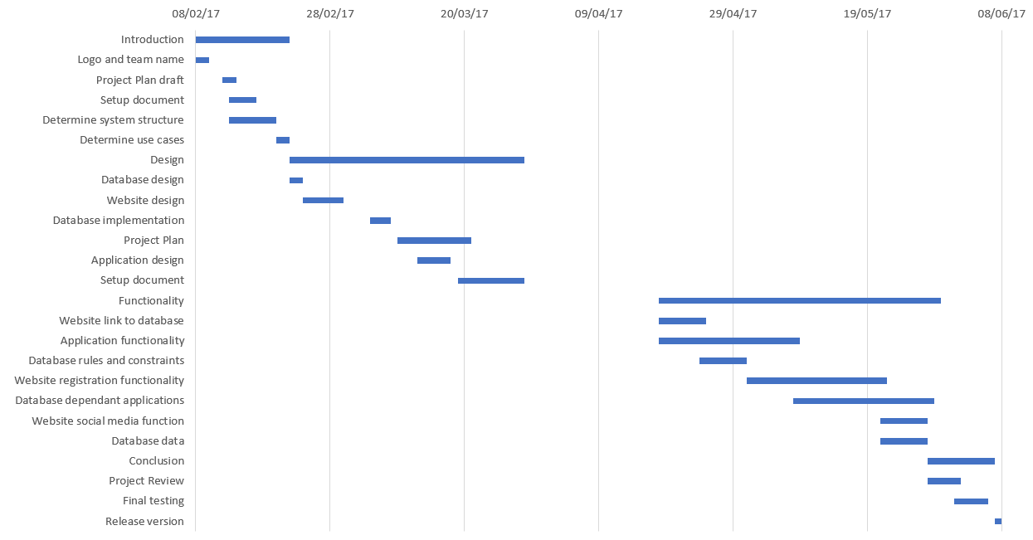

## Project Plan: System for E-Vents “Pulse Music Festival” event

Team name: Tech-Rex

Team: Daniel van Dijk (2940035)

Ryan Meijs (2980835)

Jue Wang(2769018)

Surya Giri(2880032)

Client: Jolaro Guil

Signature team Signature client